**EXPERIMENT NO. 6**

**AIM:** Creation of Simple Networking topologies using hubs and switches. 

**MATERIAL AND REQUIREMENTS**

* + Computer, Hub, Switch.

**Creation of topology network using Hub with P1 and PC2**

**Steps 1:** Open Cisco Packet Tracer

**Steps 2:**  Take two or more device or PC that is (P1 & PC2) and also take a networking device that is hub.

**Steps 3:**   Then connect both of the devices with the network device(hub).

**Steps 4:**    Assign IP address to both the PCs (P1 and P2).

**Steps 5:**    After assigning the IP verify both device using ping command that is connected to each other or ready to communicate each other or not?

**Steps 6:**   Hit ping command and check from PC1 to PC2 and vice versa.

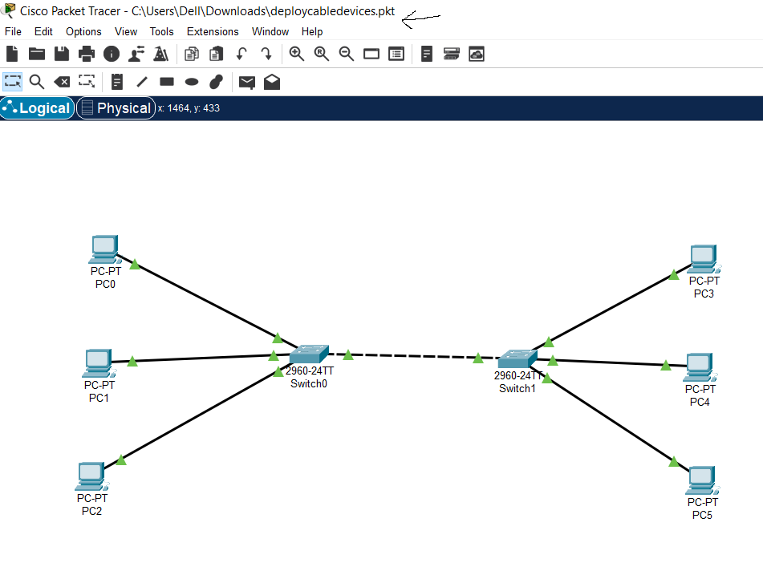

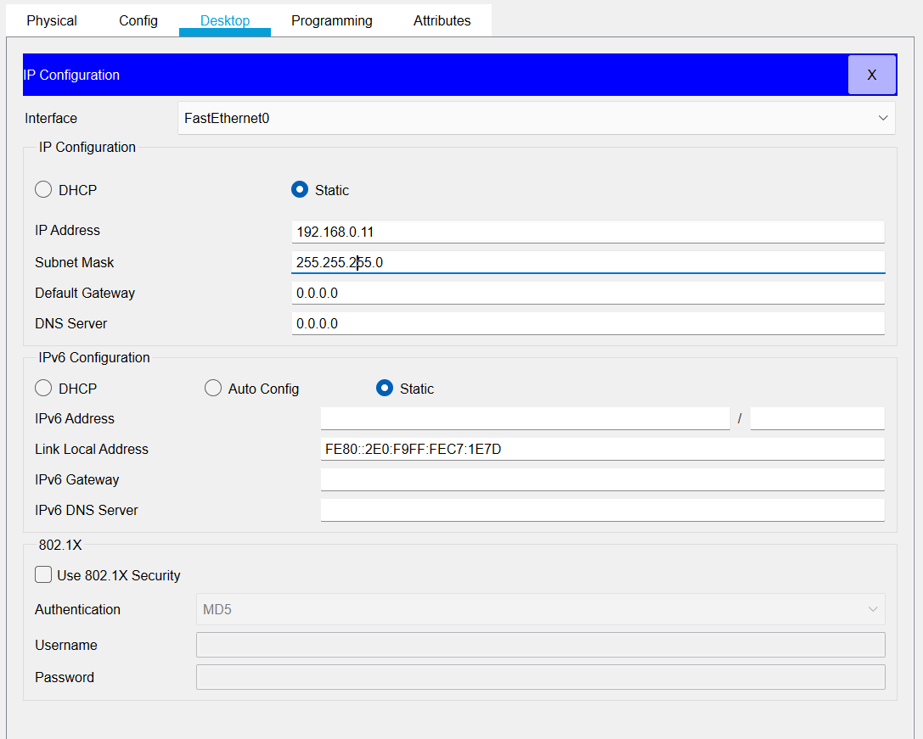

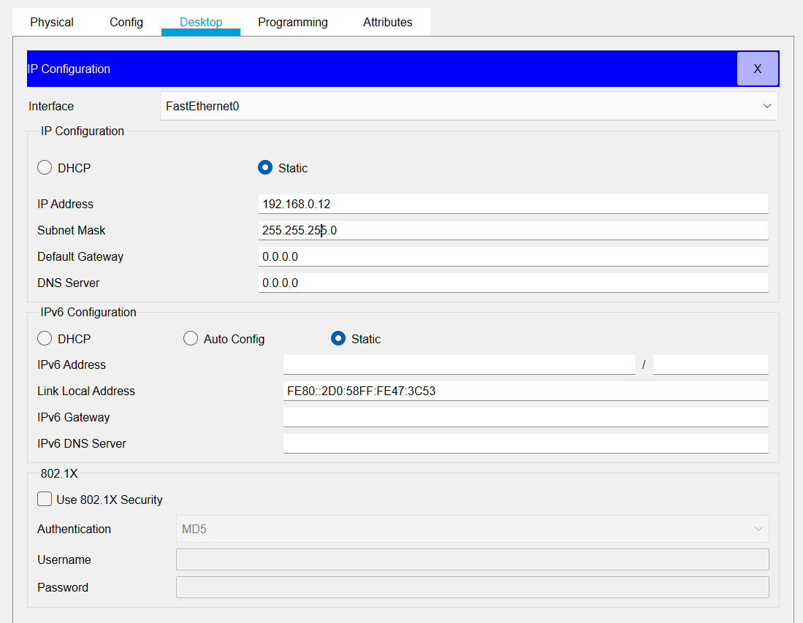

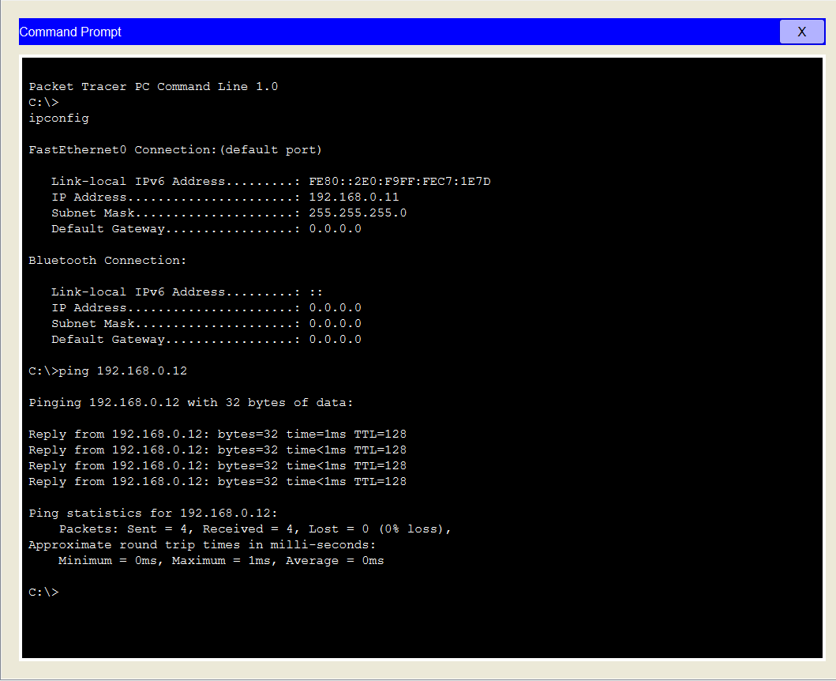

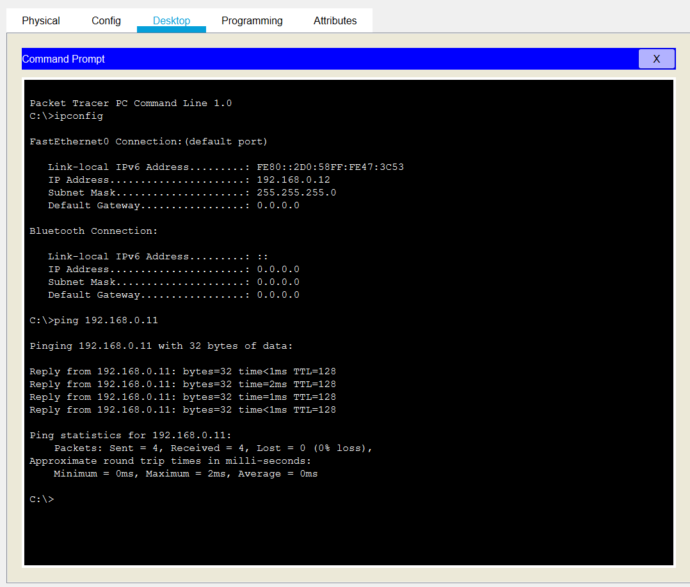

**Creation of topology network using Switch with P1 and PC2**

**Steps 1:** Open Cisco Packet Tracer

**Steps 2:**  Take two or more device or PC that is (P1 & PC2) and also take a networking device that is switch.

**Steps 3:**   Then connect both of the devices with the network device(switch).

**Steps 4:**    Assign IP address to both the PCs (P1 and P2).

**Steps 5:**    After assigning the IP verify both device using ping command that is connected to each other or ready to communicate each other or not?

**Steps 6:**   Hit ping command and check from PC1 to PC2 and vice versa

